**Inventory System – iOS Application**

System Manual

**Vision Quest**

Sai Suneel Reddy Challa

Jeevitha Kamatham

Manoj Kumar Kotte

Meghana Thakkellapati

Sahithya Vuppala

Date: 04/16/2017

Prepared for

44-691 Computer Science Graduate Directed Project – I ,II

Spring 2017

Instructor: Zhengrui Qin

Client: Zhengrui Qin

**TABLE OF CONTENTS**

|  |
| --- |
|  |
| 1. Introduction……………………...……………………………………...……….. 3 |
| 2. Installation Instructions………..…………………………………………………. 3 |
| 3. System Requirements …………………...……...…………………………........... 3 |
| 4. System Flowchart …………………………………...………………………….... 4 |
| 5. System WorkFlow….…………….………………………………………………. 5 |
| * + 1. AdminSignup……………………………………………………………...6     2. AddAnnouncment……………….………..……………………………….7     3. GuestRegistration….........…………………………………………………8     4. UserLogin…………..…………………………….………………………..9     5. UserRequests………………………………………………………………10     6. RequestApproval…………………………………………………………..11     7. Shipping Receipt…………………………………………………………..12     8. Provide card details………………………………………………………..13     9. PaymentReceipt………………………………………………………...…14     10. Payment Completion………………………………………………………15 |
| 6. Conclusion………………………………………………………………………...17 |
|  |

1. **Introduction:**

This is an iOS Mobile application that helps a businessman or businesswoman manage his or her online store.

1. **Installation Instructions:**

**Step-1:** Download Xcode from App Store into your Mac system. Launch the .dmg file you downloaded. Follow the setup wizard to install Xcode Studio.

**Step-2:** Download inventory iOS project provided

**Step-3:** Select the device you want to run on at the top left corner of Xcode and click on run icon to build and run the app. The app runs on the simulator and can use the app.

**Step-4:** To deploy the app on your mobile device. Connect your mobile device and and select your mobile device under simulator. Run the app, you will be asked to enter the developer credentials. Enter your credentials, app gets deployed in the mobile device and you can use it.

1. **System Requirements:**

There are three roles possible for the system:

**Admin Role**

* Able to announce how many items he needs at a time
* Also fix the price for each product
* Request of items should be shown in admin’s dashboard
* Need to upload a shipping label to the user
* When the product details are verified the payment will be done

**Client Role**

* Records numbers of items bought
* Asks admin for the shipping label
* User should view the shipping label uploaded by the admin
* User can download the shipping package and ship the package
* User need to upload the shipping receipt to the system

**Guest Role**

* Asks Permission to continue as a user

1. **System Flowchart:**

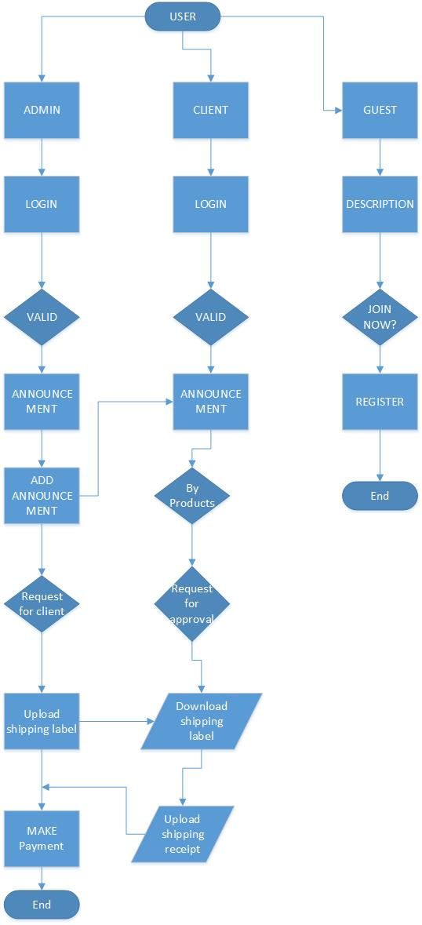

1. **System Workflow**

When a user first clicks on the Inventory system application in the mobile or tab, it asks you to choose whether you are an Admin, User or Guest

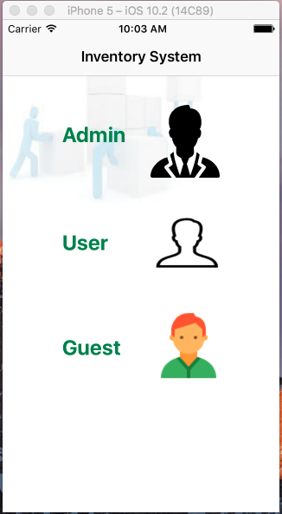

**Fig: 5.1.1 Registration screen**

* + 1. **Admin Signup**

If the user is Admin, then he can click on Admin symbol. The application provides login page for admin. If the Admin provides correct credentials, he will be able to log-in to the system. After logging in, he will able to see the announcements already posted by him previously. If he wants to add a new Announcement, he can click on Add button

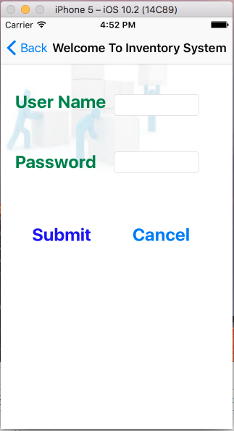 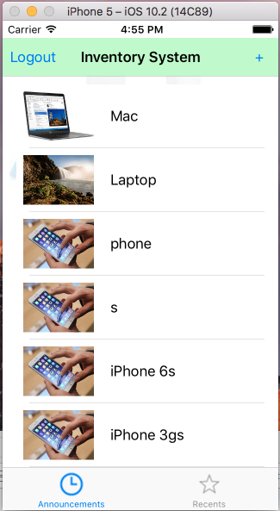

**Fig: 5.1.2 Admin login screen Fig: 5.1.3 Admin Announcements screen**

* + 1. **Add Announcement**

When admin clicks on Add button, he can add an announcement with Product name, description, quantity, price, and image. Once the Admin fills all the required fields and uploads an image for the announcement, he can click on Add button. Admin gets an alert with message “Announcement saved”

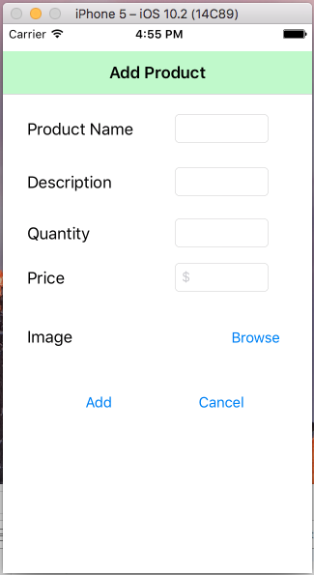 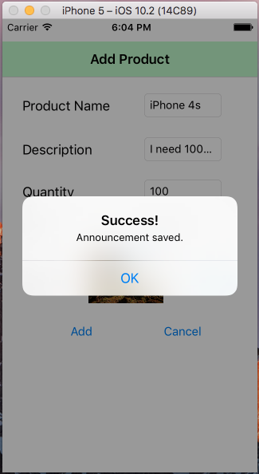

**Fig: 5.1.4 Add Announcement screen Fig: 5.1.5 Announcement saved alert screen**

* + 1. **Guest Registration**

When admin adds an announcement, client or normal user should be able to see the announcement posted. However, user should be able to log-in to system. If he or she is a new user, he/she needs to register first. Before registering, he/she will be briefed about what the system does with description. If he/she still wants to register, they can click on Join us. When clicked on Join us, he/she will be directed to Registration page. If the user provides appropriate details, registration shall be successful and user can log-in to system with his/her credentials to view Admin Announcements

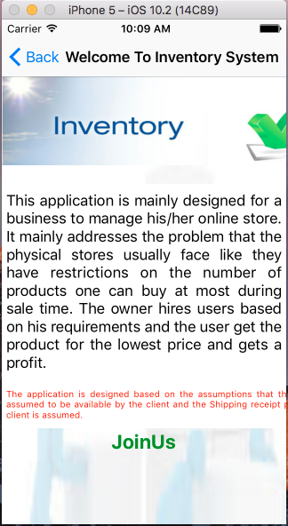 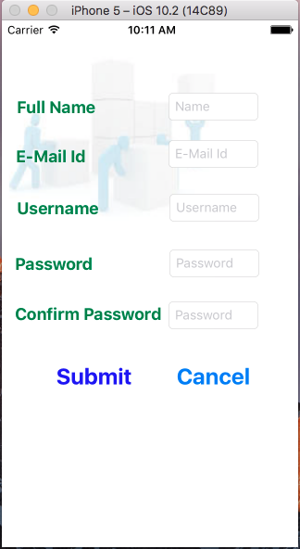

**Fig: 5.1.6 System Description screen Fig: 5.1.7 New User Registration screen**

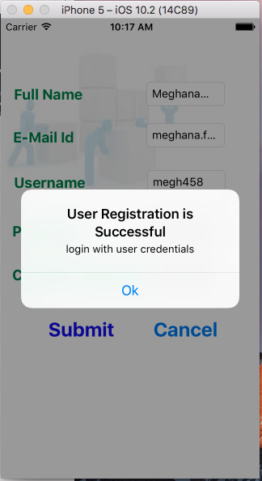

**Fig: 5.1.8 New User Registration screen**

* + 1. **User Login**

New user can login with his credentials, only if his email has been verified. After clicking on the link, the user can log-in.

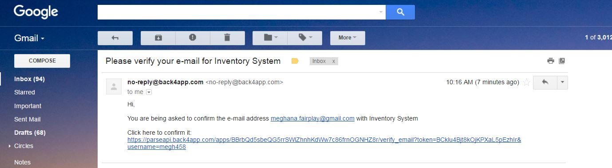

**Fig: 5.1.9 Verifying email address**

Once the user log-in, he can view the announcements created by Admin

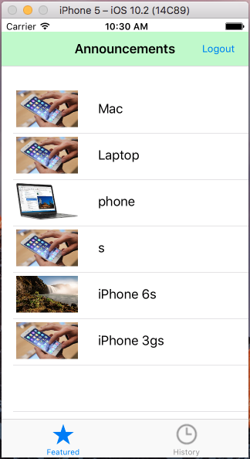

**Fig: 5.1.10 User Announcements screen**

* + 1. **User Requests**

Upon clicking on an announcement, user is navigated to a screen, where user can see the announcement details posted by Admin. Also, the user can request to buy products on behalf of admin. He/she is prompted to provide the number of products, that he/she decided to buy. When user clicks on Request button, an alert message is displayed as shown

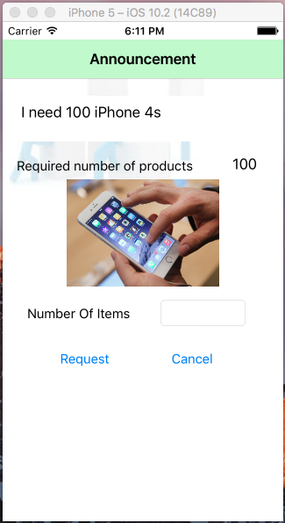 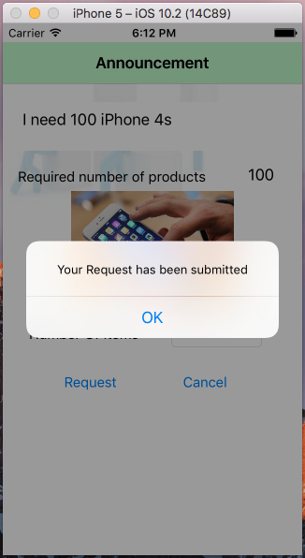

**Fig: 5.1.11 User request screen Fig: 5.1.12 Alert message for request submission**

* + 1. **Request Approval**

The user can buy the products, only if Admin approves the user request. In the Recents tab in Admin, client requests can be seen. The product name with their respective user’s, who requested the product. Once the admin clicks on the user with the product he wants to buy from user, the admin can accept or decline a user request. Once he clicks on accept button, he will be prompted with confirmation as shown

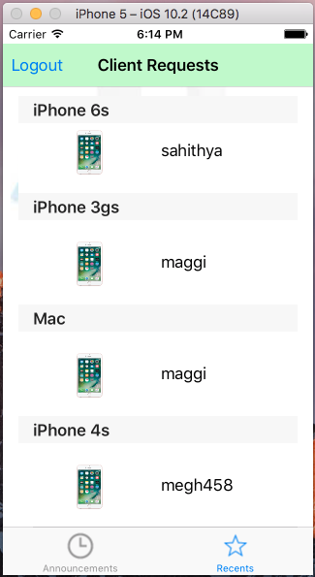 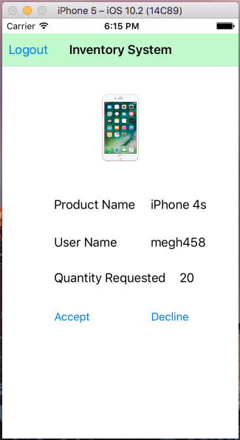

**Fig: 5.1.13 Admin client requests Fig: 5.1.14 Client Request Approve/decline screen**

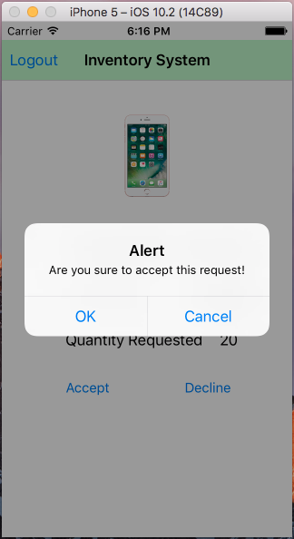

**Fig: 5.1.15 Approval confirmation alert**

* + 1. **Shipping receipt**

Upon request approval by admin, the user buys the product and uploads the shipping receipt. The user will also be provided with the billing address of the admin

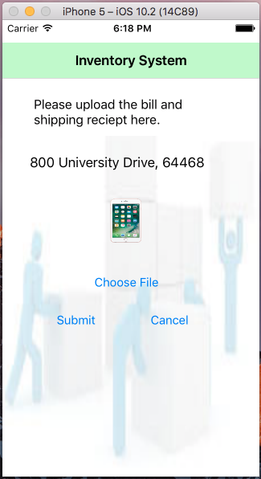 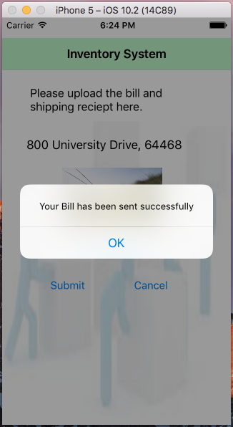

**Fig: 5.1.16 Upload shipping receipt Fig: 5.1.17 Alert message for uploading bill**

* + 1. **Provide Card details**

User is prompted to provide card details, when he/she clicked on Announcements in the Featured tab. Once the card details have been given, confirmation alert message will be provided as shown

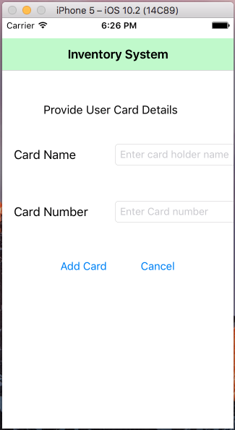 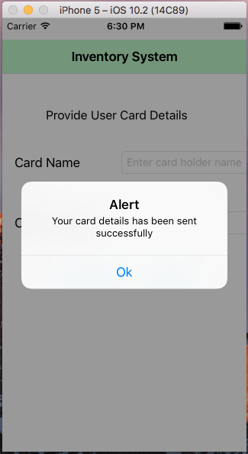**Fig: 5.1.18 Provide user credit/debit card details Fig: 5.1.19 Successful card details submission**

* + 1. **Payment Receipt**

After receiving user card details, shipping receipt along with bill for the purchase, admin initiates a payment and provides the payment details to the user

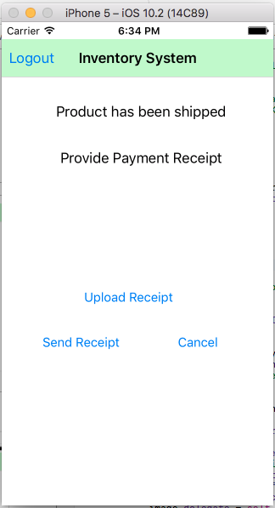 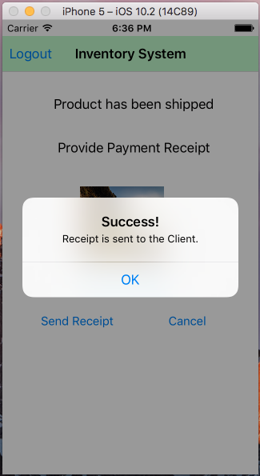

**Fig: 5.1.20 Upload payment receipt Fig: 5.1.21 Payment receipt sent alert message**

* + 1. **Payment completion**

User gets notification that payment has been initiated by admin.

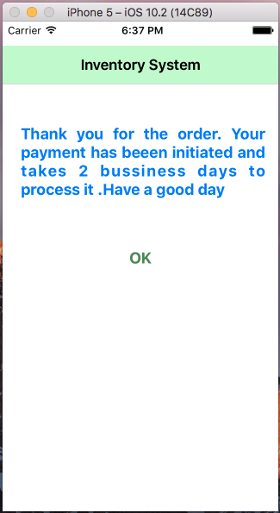

**Fig: 5.1.22 Payment confirmation to User**

1. **Conclusion**

The Admin-client workflow for the Inventory System works as shown in the workflow above. All the application data is stored in back4app. Our Inventory System application is user friendly and it supports a businessman to buy products in bulk.